**Question 1:**

import java.util.Scanner;

// Program computes and displays the greater of two numbers

public class GreaterNumber {

public static void main(String[] args) {

int num1, num2;

Scanner input = new Scanner(System.in);

System.out.println("Enter the values of num1 and num2:");

num1 = input.nextInt();

num2 = input.nextInt();

if (num1 > num2) {

System.out.println("The larger number is " + num1);

} else if (num2 > num1) {

System.out.println("The larger number is " + num2);

} else {

System.out.println("There is no greater number.");

}

input.close();

}

}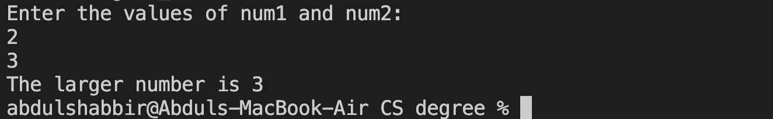

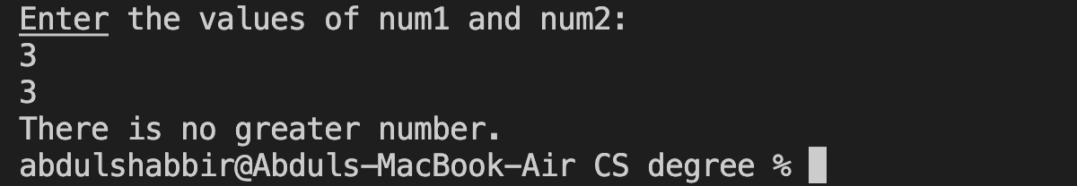

**Question 2:**

import java.util.Scanner;

// Program computes and displays greatest of three numbers

public class GreatestOfThreeNumbers {

public static void main(String[] args) {

int num1, num2, num3;

Scanner input = new Scanner(System.in);

System.out.println("Enter the values of num1, num2 and num2: ");

num1 = input.nextInt();

num2 = input.nextInt();

num3 = input.nextInt();

if (num1 > num2 && num1 > num3) {

System.out.println("The largest number is " + num1);

} else if (num2 > num1 && num2 > num3) {

System.out.println("The largest number is " + num2);

} else if (num3 > num1 && num3 > num2) {

System.out.println("The largest number is " + num3);

} else {

System.out.println("There is no largest number");

}

input.close();

}

}

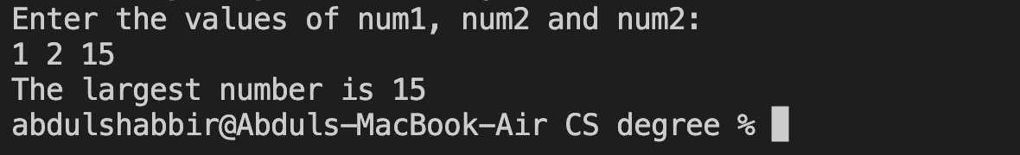

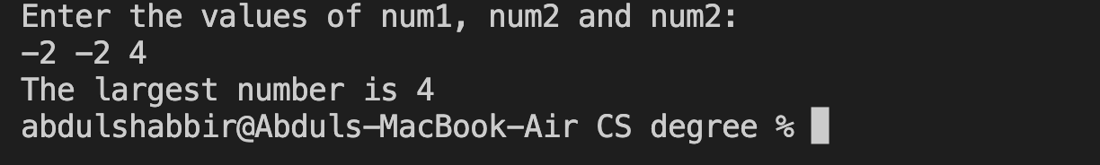

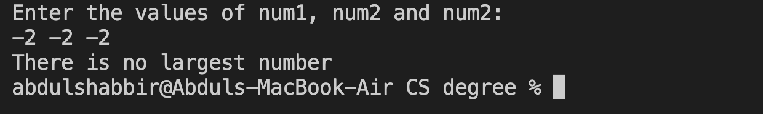

**Question 3:**

import java.util.Scanner;

// Program computes and displays the Month name from its integer representation

public class IntegerToMonth {

public static void main(String[] args) {

Scanner input = new Scanner(System.in);

int monthInteger = -1;

while (!(monthInteger >= 1 && monthInteger <= 12)) {

System.out.print("Enter an integer between 1 and 12: ");

monthInteger = input.nextInt();

if (monthInteger < 1 || monthInteger > 12) {

System.out.println("Sorry the number you entered is not an integer between 1 and 12.");

System.out.println("Please try again.");

}

}

input.close();

switch (monthInteger) {

case 1:

System.out.println("January");

break;

case 2:

System.out.println("Februrary");

break;

case 3:

System.out.println("March");

break;

case 4:

System.out.println("April");

break;

case 5:

System.out.println("May");

break;

case 6:

System.out.println("June");

break;

case 7:

System.out.println("July");

break;

case 8:

System.out.println("August");

break;

case 9:

System.out.println("September");

break;

case 10:

System.out.println("October");

break;

case 11:

System.out.println("November");

break;

case 12:

System.out.println("December");

break;

}

}

}

